Case Study: 8
Title: To generate job application form using HTML, CSS and JS, and also showing live error while user fills the details.
Software/Tools Required: VSC, HTML, CSS, JavaScript
Case Study program code:
index.html:
<!DOCTYPE html>
<html lang="en">
<head>
<meta charset="UTF-8">
<meta name="viewport" content="width=device-width, initial-scale=1.0">
<title>Online Job Application Form</title>
<link rel="stylesheet" href="style.css">
</head>

<body>

<div class="container">

<h1>Online Job Application Form</h1>
<p class="intro">
Please fill in the following details carefully. All required fields must be valid.
</p>

<form id="jobForm">

<!-- Personal Information -->
<h2>Personal Information</h2>

<div class="row">
<div class="form-group">
<label>Full Name <span>*</span></label>
<input type="text" id="name" placeholder="Enter full name">
<small id="nameError"></small>
</div>

<div class="form-group">
<label>Date of Birth <span>*</span></label>
<input type="date" id="dob">
<small id="dobError"></small>
</div>
</div>

<div class="row">
<div class="form-group">
<label>Gender <span>*</span></label>
<select id="gender">
<option value="">Select Gender</option>
<option>Male</option>
<option>Female</option>
<option>Other</option>
</select>
<small id="genderError"></small>
</div>

<div class="form-group">
<label>Email <span>*</span></label>
<input type="email" id="email" placeholder="example@gmail.com">
<small id="emailError"></small>
</div>
</div>

<div class="row">
<div class="form-group">
<label>Mobile Number <span>*</span></label>
<input type="text" id="mobile" maxlength="10"
placeholder="10 digit mobile number">
<small id="mobileError"></small>
</div>

<div class="form-group">
<label>Address <span>*</span></label>
<input type="text" id="address" placeholder="Enter address">
<small id="addressError"></small>
</div>
</div>

<div class="row">
<div class="form-group">
<label>City / State <span>*</span></label>
<input type="text" id="city" placeholder="Enter city and state">
<small id="cityError"></small>
</div>

<div class="form-group">
<label>PIN Code <span>*</span></label>
<input type="text" id="pin" maxlength="6"
placeholder="6 digit PIN">
<small id="pinError"></small>
</div>
</div>

<!-- Educational Qualification -->
<h2>Educational Qualification</h2>

<div class="row">
<div class="form-group">
<label>Highest Qualification <span>*</span></label>
<select id="qualification">
<option value="">Select Qualification</option>
<option>10th</option>
<option>12th</option>
<option>Diploma</option>
<option>Bachelor's Degree</option>
<option>Master's Degree</option>
<option>PhD</option>
</select>
<small id="qualificationError"></small>
</div>

<div class="form-group">
<label>University / Institute <span>*</span></label>
<input type="text" id="university"
placeholder="Enter university / institute">
<small id="universityError"></small>
</div>
</div>

<div class="row">
<div class="form-group">
<label>Passing Year <span>*</span></label>
<input type="number" id="passingYear"
placeholder="YYYY">
<small id="passingYearError"></small>
</div>

<div class="form-group">
<label>Percentage / CGPA <span>*</span></label>
<input type="text" id="percentage"
placeholder="e.g. 85% / 8.5 CGPA">
<small id="percentageError"></small>
</div>
</div>

<!-- Professional Information -->
<h2>Professional Information</h2>

<div class="row">
<div class="form-group">
<label>Applying For / Job Position <span>*</span></label>
<input type="text" id="position"
placeholder="e.g. Software Developer">
<small id="positionError"></small>
</div>

<div class="form-group">
<label>Total Work Experience <span>*</span></label>
<select id="experience">
<option value="">Select Experience</option>
<option>Fresher</option>
<option>Less than 1 year</option>
<option>1 - 2 years</option>
<option>2 - 5 years</option>
<option>5+ years</option>
</select>
<small id="experienceError"></small>
</div>
</div>

<div class="row">
<div class="form-group">
<label>Current / Previous Organization</label>
<input type="text" id="organization"
placeholder="Organization name">
</div>

<div class="form-group">
<label>Current Designation</label>
<input type="text" id="designation"
placeholder="Designation">
</div>
</div>

<div class="form-group">
<label>Expected Salary</label>
<input type="text" id="salary"
placeholder="e.g. ₹5 LPA">
</div>

<!-- Technical Skills -->
<h2>Technical Skills</h2>

<div class="row">
<div class="form-group">
<label>Programming Languages <span>*</span></label>
<input type="text" id="languages"
placeholder="Python, Java, C++, etc.">
<small id="languagesError"></small>
</div>

<div class="form-group">
<label>Technical Skills <span>*</span></label>
<input type="text" id="skills"
placeholder="HTML, CSS, SQL, ML, etc.">
<small id="skillsError"></small>
</div>
</div>

<div class="form-group">
<label>Certifications</label>
<textarea id="certifications"
placeholder="Enter your certifications"></textarea>
</div>

<div id="success"></div>

<div class="buttons">
<button type="reset" class="reset">Reset</button>
<button type="submit" class="submit">Submit Application</button>
</div>

</form>
</div>

<script src="script.js"></script>
</body>
</html>

Style.css:
* {
box-sizing: border-box;
margin: 0;
padding: 0;
}

body {
font-family: Arial, sans-serif;
background: #eef3f8;
color: #263238;
padding: 35px 15px;
}

.container {
max-width: 1000px;
margin: auto;
background: white;
border-radius: 12px;
padding: 35px 45px;
box-shadow: 0 8px 25px rgba(0, 0, 0, 0.12);
}

h1 {
text-align: center;
color: #173f6b;
margin-bottom: 8px;
}

.intro {
text-align: center;
color: #666;
margin-bottom: 35px;
font-size: 14px;
}

h2 {
color: #173f6b;
font-size: 20px;
margin: 28px 0 18px;
padding-left: 10px;
border-left: 4px solid #2878c8;
}

.row {
display: grid;
grid-template-columns: 1fr 1fr;
gap: 20px;
}

.form-group {
margin-bottom: 17px;
}

label {
display: block;
font-size: 14px;
font-weight: bold;
margin-bottom: 7px;
}

label span {
color: red;
}

input,
select,
textarea {
width: 100%;
padding: 12px;
border: 1px solid #cbd5df;
border-radius: 6px;
font-size: 14px;
outline: none;
background: white;
}

textarea {
height: 90px;
resize: vertical;
}

input:focus,
select:focus,
textarea:focus {
border-color: #2878c8;
box-shadow: 0 0 4px rgba(40, 120, 200, 0.25);
}

.valid {
border-color: #249b5c;
}

.invalid {
border-color: #d93025;
}

small {
display: block;
color: #d93025;
font-size: 12px;
margin-top: 4px;
min-height: 15px;
}

#success {
display: none;
background: #e7f7ed;
color: #18743e;
padding: 12px;
border-radius: 6px;
margin: 15px 0;
text-align: center;
font-weight: bold;
}

.buttons {
display: flex;
justify-content: flex-end;
gap: 12px;
margin-top: 25px;
padding-top: 20px;
border-top: 1px solid #ddd;
}

button {
border: none;
padding: 12px 25px;
border-radius: 6px;
cursor: pointer;
font-weight: bold;
font-size: 14px;
}

.reset {
background: #e5e9ee;
color: #333;
}

.reset:hover {
background: #d5dbe2;
}

.submit {
background: #173f6b;
color: white;
}

.submit:hover {
background: #0e2f52;
}

@media (max-width: 700px) {
.container {
padding: 25px 20px;
}

.row {
grid-template-columns: 1fr;
gap: 0;
}

.buttons {
flex-direction: column;
}

button {
width: 100%;
}
}
script.js:
const form = document.getElementById("jobForm");

function setError(id, message) {
const input = document.getElementById(id);
const error = document.getElementById(id + "Error");

input.classList.remove("valid");
input.classList.add("invalid");
error.textContent = message;
}

function setValid(id) {
const input = document.getElementById(id);
const error = document.getElementById(id + "Error");

input.classList.remove("invalid");
input.classList.add("valid");
error.textContent = "";
}

/* Full Name */
function validateName() {
const value = document.getElementById("name").value.trim();

if (!/^[A-Za-z ]{3,}$/.test(value)) {
setError("name", "Enter a valid name.");
return false;
}

setValid("name");
return true;
}

/* Date of Birth */
function validateDOB() {
const value = document.getElementById("dob").value;

if (value === "") {
setError("dob", "Please select your date of birth.");
return false;
}

setValid("dob");
return true;
}

/* Gender */
function validateGender() {
const value = document.getElementById("gender").value;

if (value === "") {
setError("gender", "Please select your gender.");
return false;
}

setValid("gender");
return true;
}

/* Email */
function validateEmail() {
const value = document.getElementById("email").value.trim();
const pattern = /^[^\s@]+@[^\s@]+\.[^\s@]+$/;

if (!pattern.test(value)) {
setError("email", "Enter a valid email address.");
return false;
}

setValid("email");
return true;
}

/* Mobile */
function validateMobile() {
const value = document.getElementById("mobile").value;

if (!/^[6-9]\d{9}$/.test(value)) {
setError("mobile", "Enter a valid 10-digit mobile number.");
return false;
}

setValid("mobile");
return true;
}

/* Address */
function validateAddress() {
const value = document.getElementById("address").value.trim();

if (value.length < 10) {
setError("address", "Address must contain at least 10 characters.");
return false;
}

setValid("address");
return true;
}

/* City */
function validateCity() {
const value = document.getElementById("city").value.trim();

if (value.length < 3) {
setError("city", "Enter a valid city/state.");
return false;
}

setValid("city");
return true;
}

/* PIN */
function validatePin() {
const value = document.getElementById("pin").value;

if (!/^\d{6}$/.test(value)) {
setError("pin", "PIN code must contain 6 digits.");
return false;
}

setValid("pin");
return true;
}

/* Generic required field */
function validateRequired(id, message) {
const value = document.getElementById(id).value.trim();

if (value === "") {
setError(id, message);
return false;
}

setValid(id);
return true;
}

/* Live validation */
document.getElementById("name").addEventListener("input", validateName);
document.getElementById("dob").addEventListener("change", validateDOB);
document.getElementById("gender").addEventListener("change", validateGender);
document.getElementById("email").addEventListener("input", validateEmail);
document.getElementById("mobile").addEventListener("input", validateMobile);
document.getElementById("address").addEventListener("input", validateAddress);
document.getElementById("city").addEventListener("input", validateCity);
document.getElementById("pin").addEventListener("input", validatePin);

/* Only numbers in mobile and PIN */
document.getElementById("mobile").addEventListener("input", function () {
this.value = this.value.replace(/\D/g, "").slice(0, 10);
});

document.getElementById("pin").addEventListener("input", function () {
this.value = this.value.replace(/\D/g, "").slice(0, 6);
});

/* Submit */
form.addEventListener("submit", function (event) {

event.preventDefault();

let valid = true;

if (!validateName()) valid = false;
if (!validateDOB()) valid = false;
if (!validateGender()) valid = false;
if (!validateEmail()) valid = false;
if (!validateMobile()) valid = false;
if (!validateAddress()) valid = false;
if (!validateCity()) valid = false;
if (!validatePin()) valid = false;

if (!validateRequired(
"qualification",
"Please select your highest qualification."
)) valid = false;

if (!validateRequired(
"university",
"Enter your university/institute."
)) valid = false;

if (!validateRequired(
"passingYear",
"Enter your passing year."
)) valid = false;

if (!validateRequired(
"percentage",
"Enter your percentage/CGPA."
)) valid = false;

if (!validateRequired(
"position",
"Enter the job position."
)) valid = false;

if (!validateRequired(
"experience",
"Please select your experience."
)) valid = false;

if (!validateRequired(
"languages",
"Enter your programming languages."
)) valid = false;

if (!validateRequired(
"skills",
"Enter your technical skills."
)) valid = false;

if (valid) {
const success = document.getElementById("success");

success.style.display = "block";
success.textContent =
"✓ Application submitted successfully!";

window.scrollTo({
top: document.body.scrollHeight,
behavior: "smooth"
});
}
});

/* Reset */
form.addEventListener("reset", function () {

setTimeout(() => {

document.querySelectorAll("input, select, textarea")
.forEach(element => {
element.classList.remove("valid", "invalid");
});

document.querySelectorAll("small")
.forEach(element => {
element.textContent = "";
});

document.getElementById("success").style.display = "none";

}, 50);
});
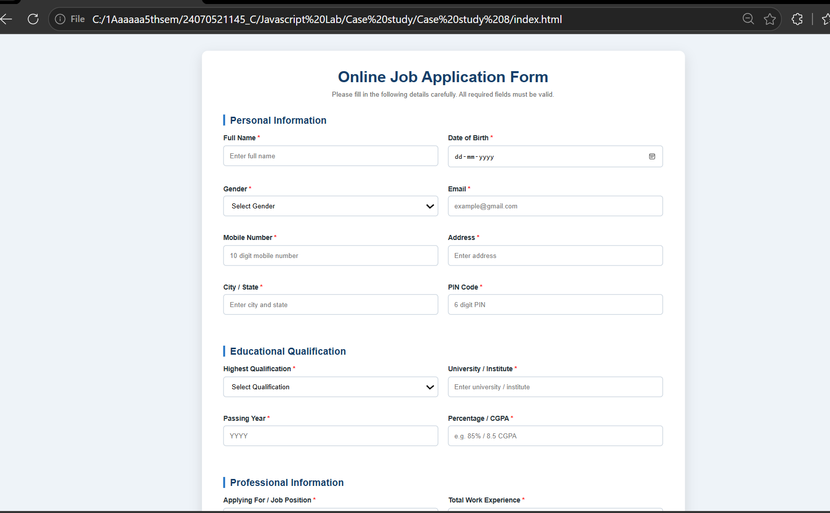
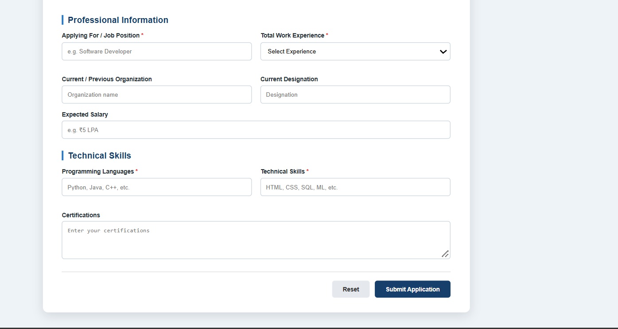

Result: The code was implemented successfully using html, css and js and online form was generated.

